**Assignment 1**

1: c) 15

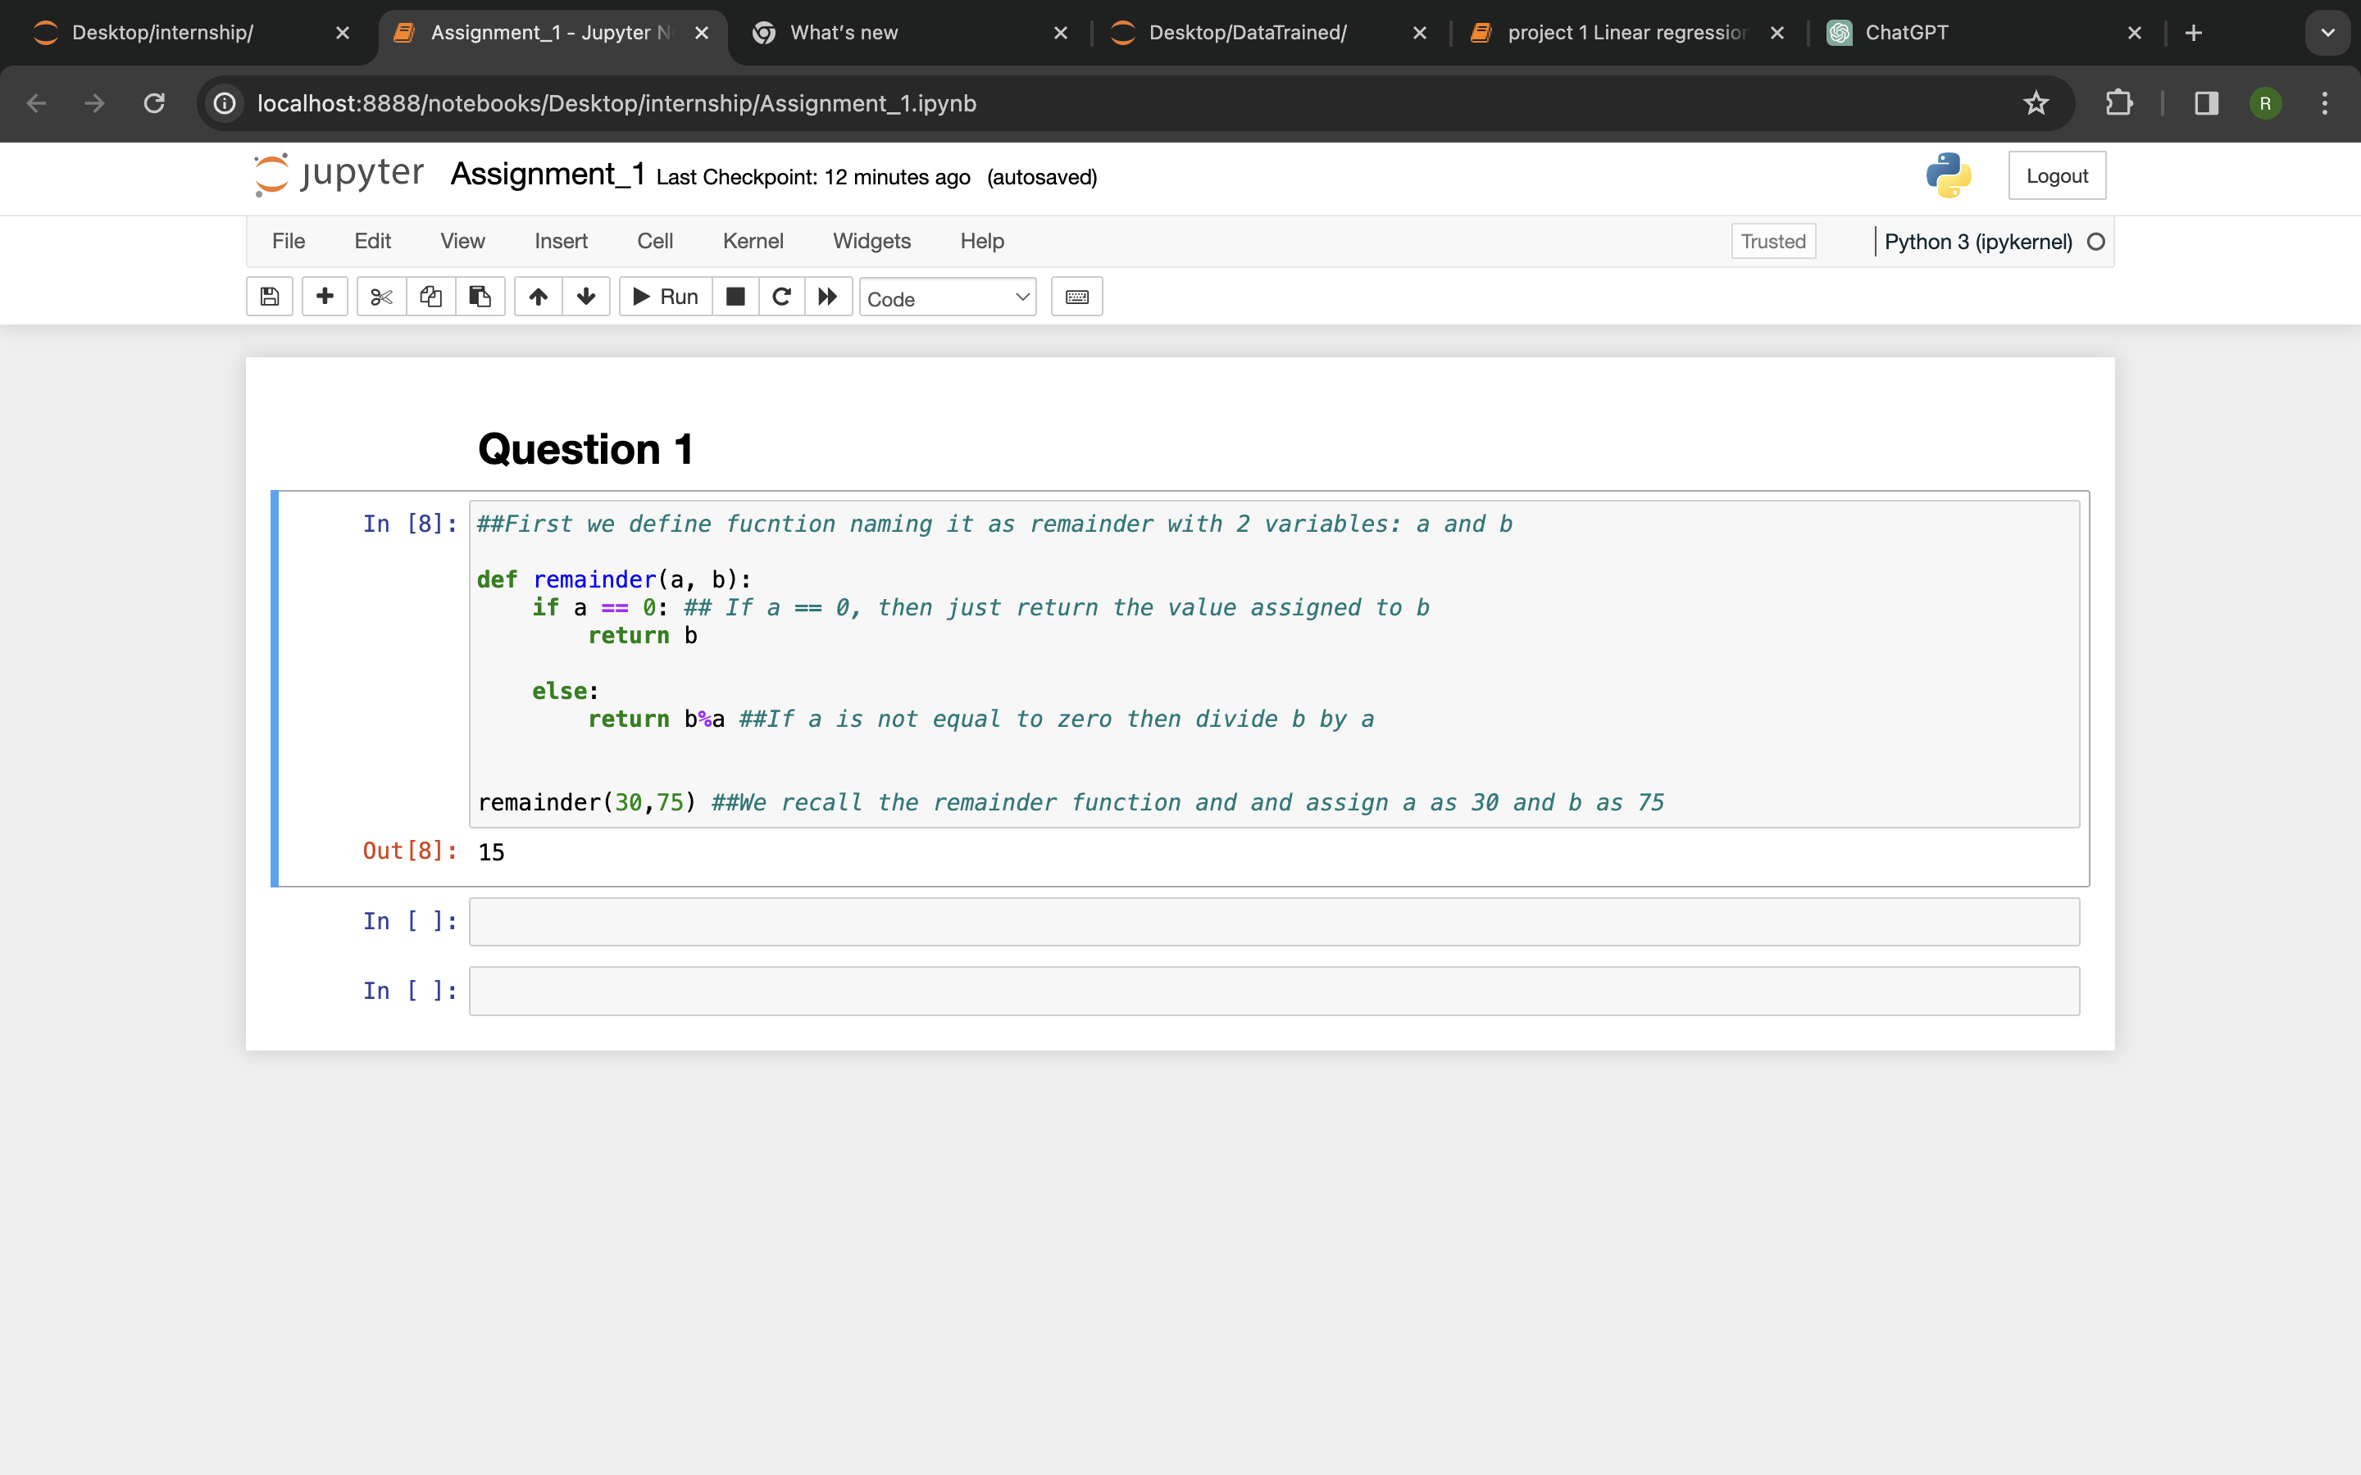

2: b) filter

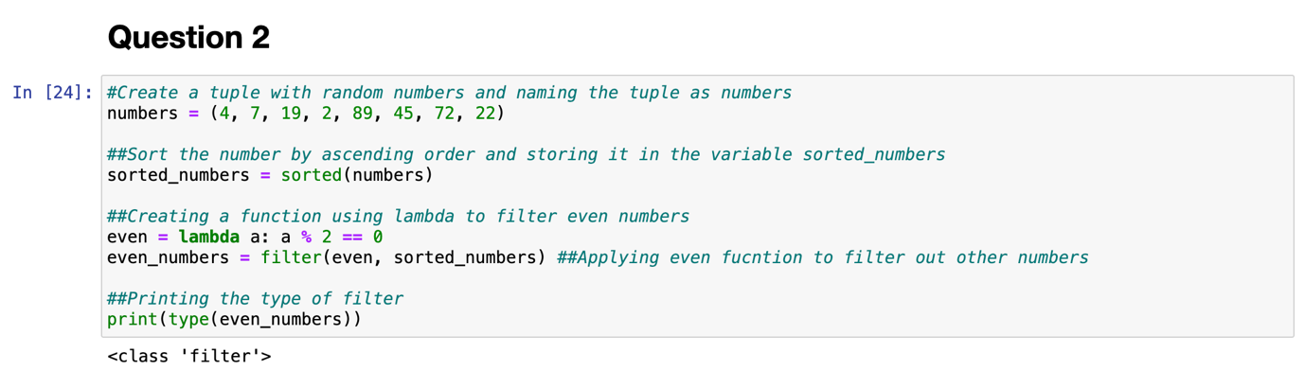

3: a) Tuple

4: d) Error

5: a) Raise

6: c) datetime

7: c) 208



8: d) None

9: b) immutable

10: a) range

11: c) lambda function

12: c) Both A and B

13: d) None of the mentioned above

14: a) load()

15: d)All of the mentioned above

16: a) for ship, captain in captains.items():

print(ship, captain)

17: d) captains = {}

18: c) captains = {

"Enterprise": "Picard",

"Voyager": "Janeway",

"Defiant": "Sisko",

}

19: b) for ship, captain in captains.items():

print(f"The {ship} is captained by {captain}.")

20: c)

